In this tutorial, you will learn

* What is UiPATH?
* Products of UiPath
* Features of UiPath
* How to install UiPATH?
* Understanding UiPATH Interface
* Sample Script using UiPath
* UiPath Vs. Other Automation Tools

**What is UiPATH?**

More and more companies are adopting Digital day by day. With digitization, the biggest advantage is the speed of execution. But the challenge with digitization is that it requires diverse tools and hence manpower with diverse skillset is required to handle those tools. But workforce having varied skill set is scarce. To resolve this issues the entire IT industry has been looking for reliable, fast, intelligent, robust solution. This demand is fulfilled by UI path.

UiPath Studio software solution allows automating repetitive office tasks. It is founded by Romanian entrepreneur Daniel Dines in the year 2015. It converts boring tasks into automation process can work with multiple tools.

**Products of UiPath**

UiPath studio is available with three different product suite:

**UiPath Studio**

It allows us to plan any automation processes visually with the help of different diagrams. Each diagram represents a certain type of work to perform.

**UiPath Robot**

Once you are done with the designing of processes in the studio, you need to execute the processes built in Studio. Robots will pick those steps and run without human direction in any environment. It can also work when human triggers the process.

**UiPath Orchestrator**

This tool is a web-based application. It helps you to deploy, schedule, monitor, manage robots & processes. It is a centralized platform for all the robots to manage.

**Features of UiPath**

**1. Hosting Options:**It can be hosted in cloud environments or virtual terminals.

**2. Application Compatibility:**Offers a high range of applications to work with, which includes web and desktop applications.

**3. Centralized repository:**This feature helps for handling all the robots simultaneously by users.

**4. Security:**Offers auto login features to run the bots

**5. Advanced screen scraping solution:**Scraping solution that works with any application like,.Net, Java, Flash, PDF, Legacy, SAP, with absolute accuracy.

**6. Reliable tool for modeling business processes:** The UiPath studio offers automation excellence with the help of model business processes.

**7. Level of scalability and Robustness:**

* Effective debugging and exception handling mechanisms
* Artificial intelligence handling day to day applications like outlooks excel, PDF

**How to install UiPATH?**

**Step 1)** Enter this URL in your browser: https://www.uipath.com/community. Click on get community edition button

**Step 2)** Enter all the marked details

**Step 3)** Click Request Community Edition

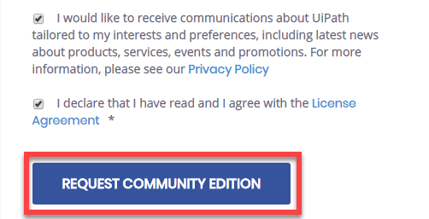

**Step 4)**You will receive a mail below. Click on **download community edition** your download will begin.

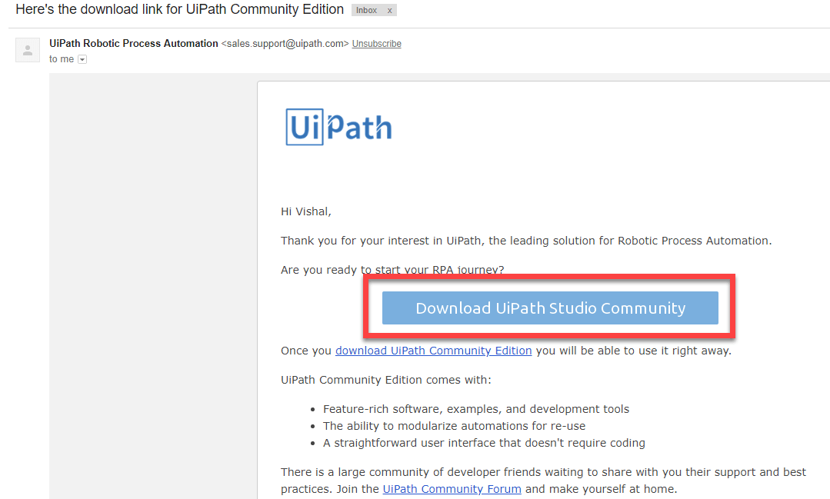

**Step 5)**Once the download is completed click on the setup file

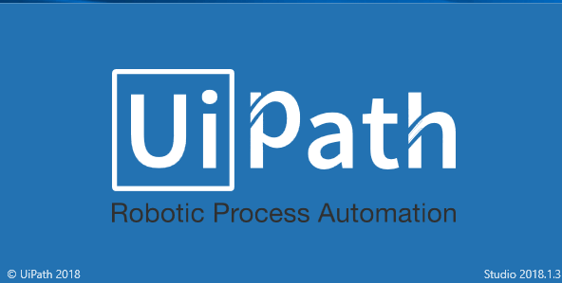

**Step 6)** Once the software is installed click on start free trial

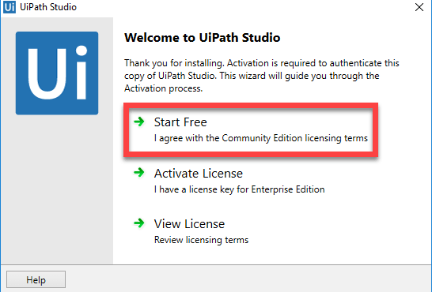

**Step 7)** In next screen,

1. Enter Email address and click on activate button.
2. Device id will be detected automatically.
3. Then Click on Activate button.

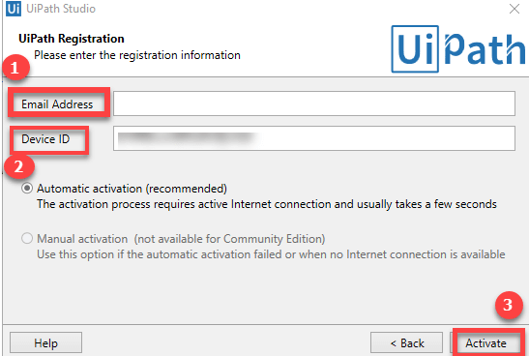

You will have Ui Path on your system now!!!

**Understanding UiPATH Interface**

UiPath has GUI which consist of multiple panels. It offers easier access to specific functionalities.

Following are the main components of UiPath Studio:

* The Ribbon
* The Universal Search Bar
* The Activities Panel
* The Library Panel
* The Project Panel

**The Ribbon:**

It consists of the following four tabs:

**1. Start** – It helps in to create any new project or to open a previously created task. By default, all the projects are created in C:\Users\Username\Documents\UiPath.

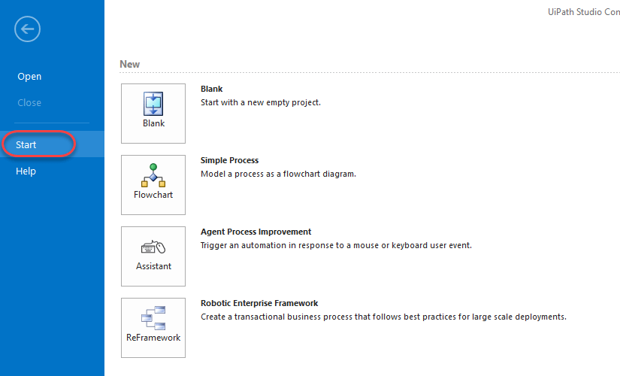

**2. Design** – It offers all the options to create or launch any sequences, flowcharts or, access wizards and, manage variables.

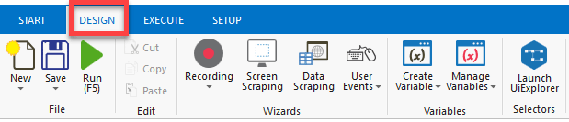

**3. Execute** –It will help in running or stop any projects. Before starting the debug process, it will slow down steps and open logs.

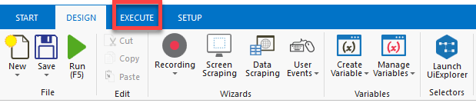

**4. Setup** – To publish a project or create a shortcut for it, schedule tasks, and install extensions

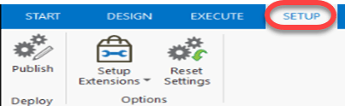

**The Universal Search Bar:**

The Universal Search bar allows the user to search for anything contained in the libraries, activities, project and the Designer panels.

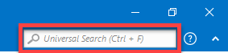

**The Activities Panel:**The Activities panel allows quick access to all available activities that can be dragged to the current project.

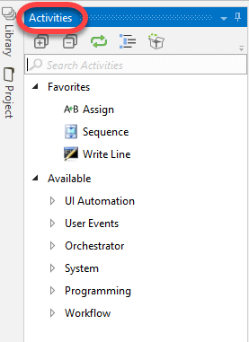

**The Library Panel:**The Library panel allows you to reuse automation. A search box is also given to find items faster.

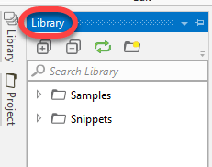

**The Project Panel:**The Project panel allows to view the contents of the current project and open the file location in a Windows Explorer.

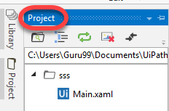

**Sample Script using UiPath**

Following are steps to create a sample UiPath Script

**Step 1)** Click on the "Blank" icon, boxed in the below image:

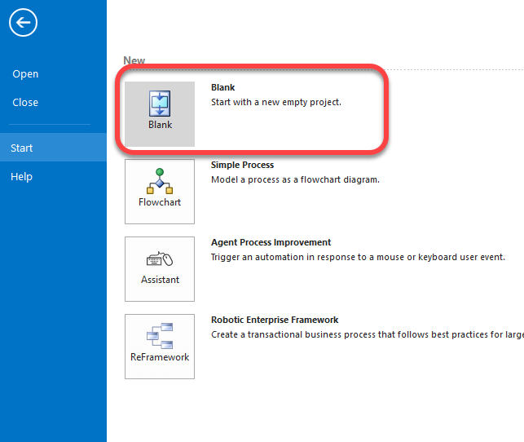

**Step 2)** In the next screen,

1. Enter the name of the project
2. Click Create Button

**Step 3) In next screen,**

1. Click on Recording
2. Select "Basic."

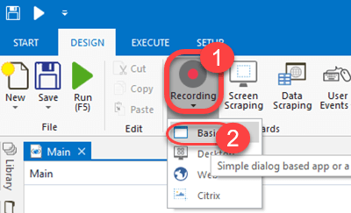

**Step 4)**This opens a small window having an icon to record as below. Click on the Record button

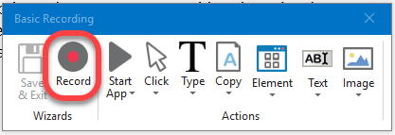

**Step 5)** Once this icon is clicked, you will see the cursor turning into hand icon and the entire screen turning into blue and highlighting all icons around it as shown below.

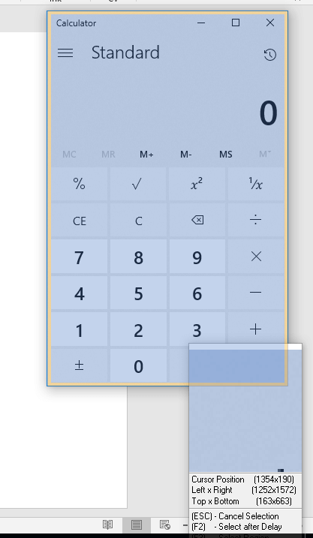

**Step 6)** Perform the manual tasks that you want to automate. UiPath will automatically create the sequence of your mouse/keyboard actions.

Once recording is done, click Save and Exit

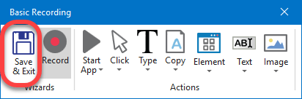

**Step 7)**You will see sequence of recorded steps as below

**Step 8)**Then click on the run icon. UiPath would repeat back the recorded actions.

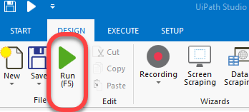

This is a basic way to create small automation robots. UiPath has lots of advance features to create more complex robots.

**UiPath Vs. Other Automation Tools**

We have many automation tools already the market like Selenium, Waite. These software's or frameworks generally perform best on web automation but fail miserably when you try to automate desktop applications or any remote applications etc.

Areas, where RPA tools like UiPath surpass existing technology, are:

* Desktop Automation
* Remote applications
* Data handling techniques
* Scrapping techniques
* The methodology of writing the logics

**Conclusion:**

* UiPath Studio software solution which automates repetitive office tasks.
* UiPath studio is available with three different product suite: 1) UiPath Studio 2) UiPath Robot 3) UiPath Orchestrator
* It can be hosted in cloud environments or virtual terminals
* UiPath offers advanced screen scrapping solutions
* Important components of UiPath Studio are 1) The Ribbon 2) The Universal Search Bar 3) The Activities Panel 4) The Library Panel 5) The Project Panel
* RPA tools like UiPath surpass existing technology in areas like Desktop Automation, Remote applications, Data handling techniques, Scrapping techniques, etc